**Abstract (w/ keywords)**

The unmanned underwater vehicle (UUV) placed in the System Dynamics and Control Lab of GIK Institute, has been developed from scratch and much of the mechanical body of the vehicle has been constructed. The thrusting mechanism of the vehicle is of prime importance. The thruster mechanism of the UUV is a magnetic coupling. Due to the risk of water entering into the electric circuits of the motor, this coupling was designed. Currently the thruster mechanism of the UUV is being controlled using a DC Motor. The angular speed of the motor can easily be varied, however, at the moment the vehicle encompasses an open-loop mechanism. In other words, whenever the speed of the motor exceeds a certain threshold value, the slippage tends to occur. In order to rectify the problem of slippage, a close-loop control system needs to be incorporated into the thruster mechanism. This project identifies the reason for slippage and discusses a detailed approach used to rectify this problem under unfavorable water conditions.

**Acknowledgements**

**Table of Contents**

**List of Figures**

**List of Tables**

**Nomenclature**

1. **Introduction**
   1. **Introduction to Controls Lab in FME**

Control lab was established by SMA in 2013. I it sit experiments like quadcopter, UAV 1DOF tail plane, Precision linear slider, Inverted pendulum, Water tank system (temperature control and level control). All these projects are under construction. Idea is to construct components in-house, stop buying them off-te-shelf as this not only is cost-effective but also provides opportunity for learning. These are the projects which are being worked as course projects.

Major projects in the controls lab that are being worked on by MS students are Active Magnetic Bearing and Magnetic Coupled thruster.[refer to ahad’s and rizwan’s papers].

Scope of these lab projects and how they contribute to professional development.

* 1. **Introduction to UUV**
  2. **Advantages and Disadvantages of Magnetic Coupling Mechanism**
  3. **Problem Definition**

Unmanned underwater vehicles (UUVs) are a crucial component of the oceans research and require reliable thrusting mechanisms for their traverse inside the water. At first, it may seem like they are solvable by an open-loop control system. However, this initial perception fails to account for the potential slippage prone to occur in unfavorable water condition. By re-thinking our approach to accommodate the closed-loop control system into the thruster mechanism, we can fix the problem of slippage via error correction.

[talk about the difference in rpm etc]

* 1. **Phases of the project**

The aim of the project is to build a working close-loop control system to prevent the slippage of the magnetically coupled thruster mechanism of the unmanned underwater vehicle sitting in the System Controls Lab at the Faculty of Mechanical Engineering, GIK Institute.

* + 1. **Theory**
    2. **Design**
    3. **Building**
    4. **Testing**
  1. **Modeling and Design Strategy for the Slippage Removal**

This project addresses the control of the thruster mechanism of the UUV. In this endeavor, the main problem that arises is that of the slippage of the across the magnetic coupling of the thruster mechanism. When the vehicle encounters unfavorable aquatic conditions, slippage is prone to occur.

In order to solve this problem, this project aims to incorporate a closed-loop control system into the system. Whenever the slippage occurs in the system, the proposed control system must detect the difference in the speed of the motor and the thruster whenever the slippage occurs. It must then measure the difference in the two speeds and then correct the error by adjusting the input as favorable by the temperament of the vehicle.

In order to sense the speed of the DC motor and the thruster, a tachometer is utilized. The tachometer is a device used to measure the angular speed of a rotating shaft and report it to the Arduino controller. Whenever the controller detects a difference in speed of the thruster versus the speed of the tachometer, we obtain the error reading.

Since the ability to purify the water is expected at a future stage of the development of the UUV, the next optimal option is to slow down the speed of the DC motor to a rate at which the slippage does not occur. In order to compute this speed, the controller shall drop the speed of the DC motor to slightly lesser than the speed of the thruster under slippage.

* 1. **Report Structure**

1. **Preliminary Concepts**

These contents form an essential component of the course Applied System Dynamics and Control offered by Faculty of Mechanical Engineering. The course is offered in fall semester and in 2015 was taught by Dr S M Ahmad. Minimum software knowledge is MATLAB Simulink.

The course provides a window of opportunity for self-learning of students, and they are encouraged to do projects based on the theory lesrnt in class. In fact, first few lectures determine the direction of the course, which is meant to essentially support the projects of the students.

* 1. **PWM**
  2. **Potentiometer**
  3. **Block Diagram**
     1. **Controller**
     2. **Actuator**
     3. **Plant**
     4. **Sensors**
     5. **Closed-loop Feedback**
  4. **Transfer Function**
  5. **FlipFlop Logic Gate**
  6. **Summary**

**[ref to books both a lot]**

1. **Theoretical Model of the Project**
   1. **Block Diagram**

**[discuss all the blocks… 3.1.1, 3.1.2, …]**

* 1. **Transfer Function**
     1. **TF of DC Motor**
     2. **Overall Transfer Function**
 $${\dot{θ}}_{th}\left(s\right)=K_{th}\left(s\right)T_{dn}\left(s\right)$$

 $${\dot{θ}}_{th}\left(s\right)=K_{th}\left(s\right)((K_{dr}(s){\dot{θ}}_{dr})-T_{d}\left(s\right))$$

2. **State Space Model**

1. **Experimental Setup**
   1. **Components Used**
      1. **Magnetic couplings**
         1. **Magnets used**
         2. **Selection of the Coupling Radius for this project**
         3. **Polarity of the Magnets**
      2. **DC Motor**
      3. **Hall Effect Sensors**

The Hall Effect sensors used were Allegro Microsystems A1302. They are available in the controls lab. Data sheet is available at http://www.allegromicro.com/~/media/Files/Datasheets/A1301-2-Datasheet.ashx

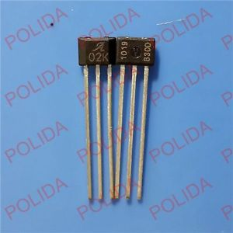[ http://i.ebayimg.com/images/g/K6oAAOxywh1TCvAR/s-l300.jpg]

* + 1. **H-Bridge L298N**

**Voltage rating and power ratings**

* + 1. **Aluminum Frame**

Hole specifications and bearing specs and places utilized (FME workshop and 3star Engineering shop of Topi Bazar)

[also discuss the actual frame that is made of acrylic disks]

* 1. **Circuit Diagram**
  2. **Computer Model**

The physical experimental setup is controlled via Wolfram ® SystemModeler. A brief tutorial of the software and its components has been provided in the appendix XX. The subsequent sections give the sequential detail of the working of this simulation.

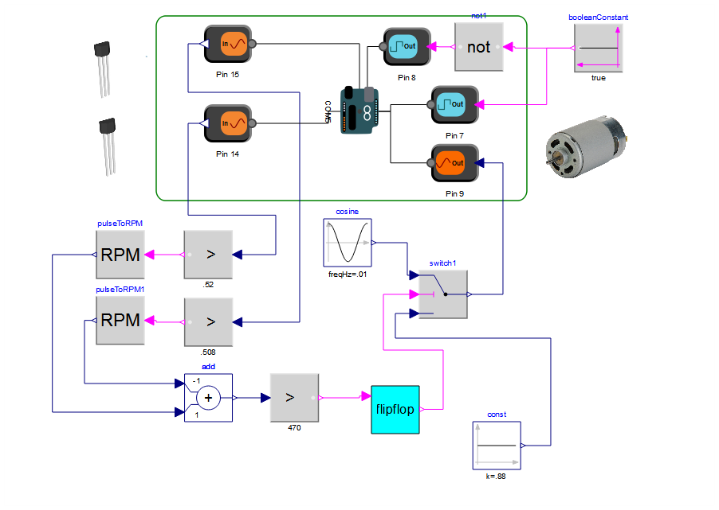

* + 1. **Arduino Block**

The COM port of the Arduino block is set according to the port number given by the Arduino IDE as described in the appendix. The pins A0 and A1 have been configured to receive analogue input from the sensors. This input is the pulses recorded from the driver and the driven wheels. The gain scale of the Analogue input is set from 0 to 5 in order to comply to the input voltage of +5V received by the hall effect sensors from the arduino 5 volt pin.

* + 1. **GreaterEqualThreshold**

The GreaterEqualThreshold blocks are set at 2.6. This is because the minimum output voltage by the hall effect sensors is 2.5, and 2.6 provides enough threshold to detect a pulse and send a Boolean signal ahead to the RPM blocks for RPM computation.

* + 1. **RPM blocks**

The two RPM blocks receive the respective input signals and output the RPMs. These blocks are not a part of the SystemModeler library. Its code has been written in guidance with the wolfram community.

* + 1. Add block

This block here simply computes the difference of the RPMs of the two rotating plates.

* + 1. FlipFlop

This block

MUST INCLUDE

* 1. **Comparison of Experimental Setup Model with Theoretical Modeling**

1. **Methodology**
   1. **Testing for operating conditions using the potentiometer**

Since it is not possible to simulate the sensors as needed, a potentiometer was used

This section includes : how I reached experimentsl setup.. step by step all the way ill finished work

1. **Results**

(graphs etc)

1. **Conclusions**
   1. **Conclusion 1**
   2. **Conclusion 2**
   3. **Conclusion 3**
   4. **Conclusion 4**
   5. **Conclusion 5**
   6. **Conclusion 6**
2. **Summary**
3. **Recommendations for Further Work**
   1. **Recommendation 1: Improved algorithm**
   2. **Recommendation 2:**
   3. **Recommendation 3:** Modeling in Planar Mechanics
4. **Appendices**
   1. **Appendix A: Using Arduino**
   2. **Appendix B: Introduction to Wolfram® SystemModeler**
      1. **Connecting Arduino to Wolfram SystemModeler**
         1. **Usage of Arduino IDE**
            1. **Firmata**
            2. **COM Port**
      2. **Description of the components used**

Not how they’ve been used but the general use

1. **References**

**[ahad’s work, franklin and dorf, ]**

* Include a note that this report is for the partial fulfillment of the course. THIS MUST INCITE a psychology in sma to ignore this repost and know that this works so he gie me full marks and
* SJ on where sma wants to see this project (will gie you disproportionate results) and vision of sma for this lab
* Do sj on viion and where sma wants to see this project
* Sj on where sma wants to see this lab
* Sj on where sma wants to see fme
* ORM BABY!
* EXPLAIN the code block diagram etc the way ramit explains interviews with his students on the sales pages